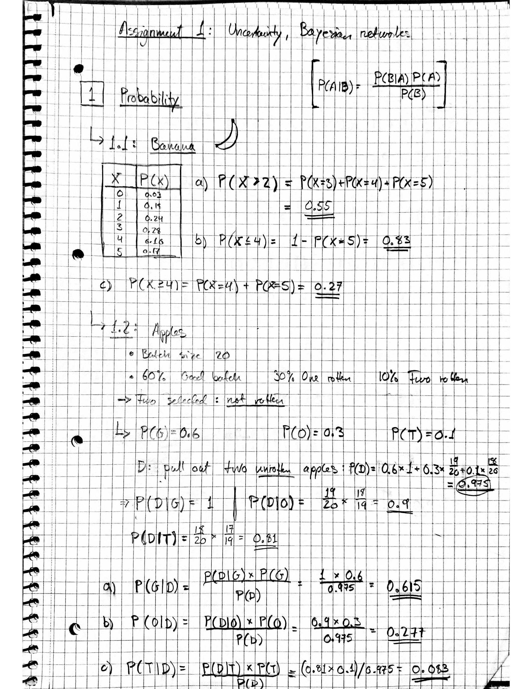

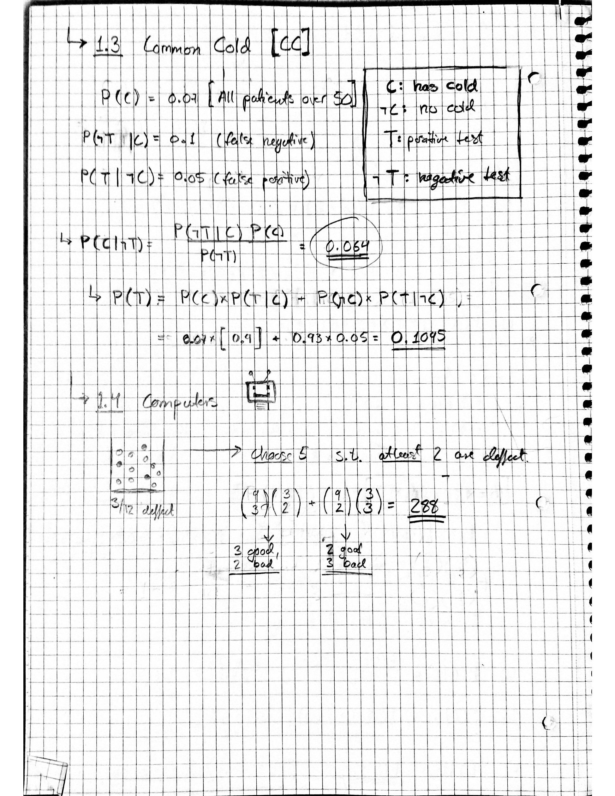

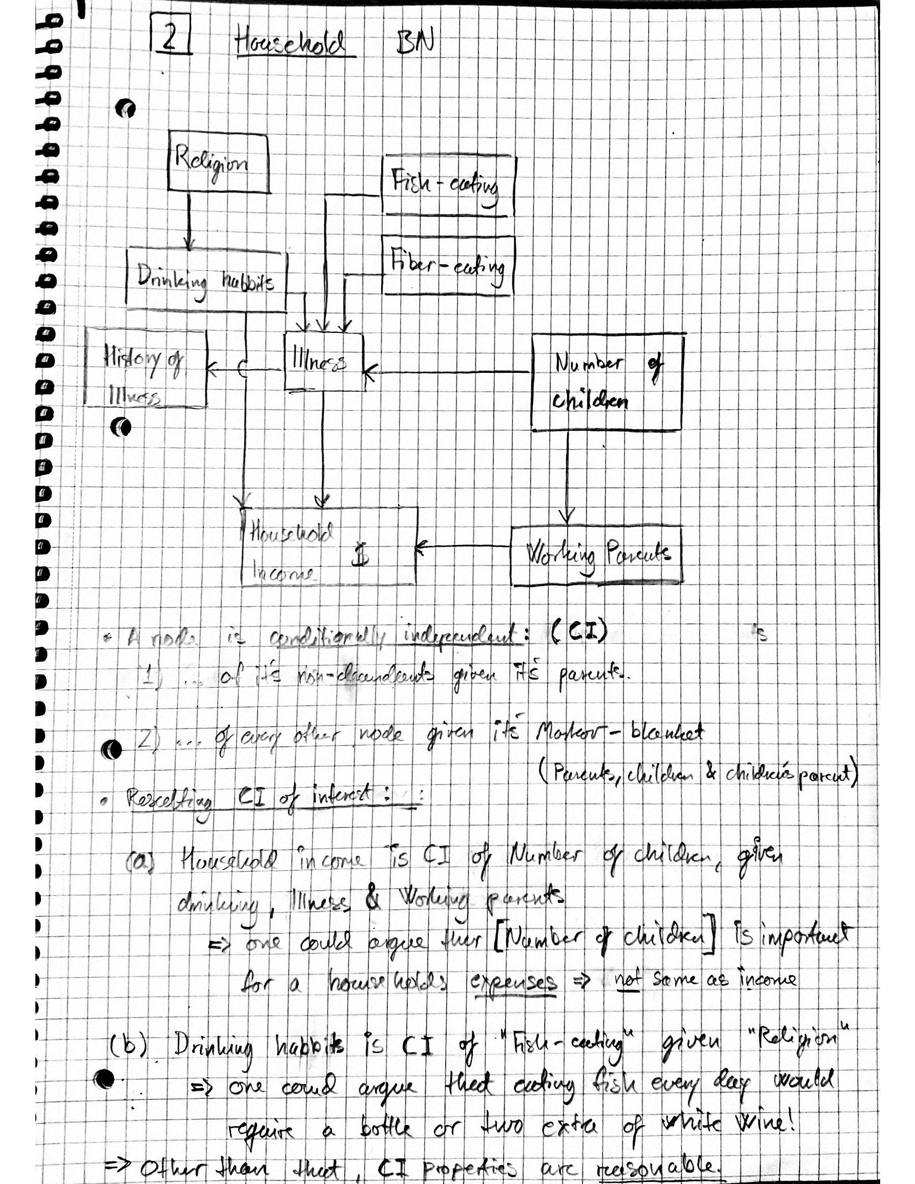

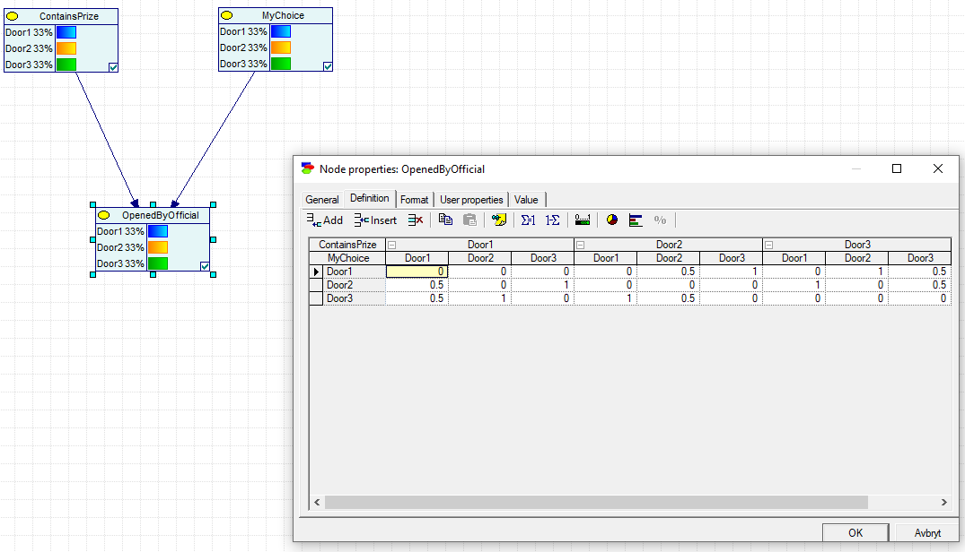3: Mounty hall (with GeNIe)

3.1: Initial setup of the problem in GeNIe. Nodes and conditional probability table for “openedByOfficial”-node.

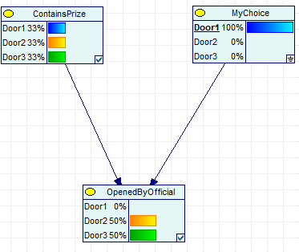

3.2: selecting door1 initially will only change what door the official can open.

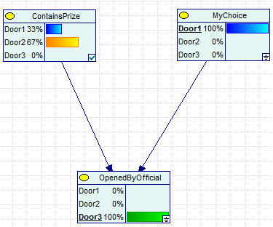  
3.3: After the official then opens one of the gates we se an interesting change: now there is a 67% probability of the prize being behind door 2.

**Conclusion:** Always change your choice of door after the officials opens a door, and here is why.

* Before a door is opened the prize could be anywhere (33% for each).
* After you choose a door, you could be correct (33%) or wrong (67%).
* After the official opens a door, the probability of being wrong on the first choice is still (67%) and therefor you could switch door (now there are only two doors, a binary True/false problem) and be right with a probability of 67%!

Henrik Fjellheim. 26.01.2020